**Assignment 10**

**Name: Hitesh Tolani**

**Roll no: 73**

**Class: SY-AIDS-A**

**Title: Write a program using UDP Sockets to enable file transfer (Script, Text, Audio and Video one file each) between two machines.**

**Theory:**

UDP (User Datagram Protocol) is a connectionless transport layer protocol used in computer networking. It's one of the core members of the Internet Protocol Suite, alongside TCP (Transmission Control Protocol). UDP provides a way for applications to send messages (datagrams) to other hosts on an IP network without requiring prior communication to set up special transmission channels or data paths

**Code:**

**udp_server.py**

import socket

MTU = 1500

ext = [".py",".txt",".mp3",".mp4"]

s = socket.socket(socket.AF_INET,socket.SOCK_DGRAM)

port = 123

s.bind(('',port))

idx = 0

while True:

    data, addr = s.recvfrom(MTU)

    if data == b"END":

        break

    if data == b"transmission started":

        with open(f"output{ext[idx]}", "wb") as file:

            while True:

                data, addr = s.recvfrom(MTU)

                if data == b"transmission completed":

                    break

                file.write(data)

        print("File received!")

        c_msg = 'File transferred successfully!'

        s.sendto(c_msg.encode(), addr)

        idx += 1

    else:

        c_msg = "File transfer failed: No data received"

        s.sendto(c_msg.encode(), addr)

s.close()

**udp_client.py**

import socket

MTU = 1500

file_paths = []

print("Enter path of script file, text file, audio file and video file one by one")

for idx in range(0, 4):

    file_paths.append(input())

for file_path in file_paths:

    with open(file_path, "rb") as file:

        data = file.read()

    port = 123

    if data:

        s = socket.socket(socket.AF_INET, socket.SOCK_DGRAM)

        start_msg = "transmission started".encode()

        end_msg = "transmission completed".encode()

        s.sendto(start_msg, ("127.0.0.1", port))

        if len(data) <= MTU:

            s.sendto(data, ("127.0.0.1", port))

            s.sendto(end_msg, ("127.0.0.1", port))

        else:

            num_packets = (len(data) - 1) // MTU + 1

            for packet_num in range(num_packets):

                start = packet_num * MTU

                end = min((packet_num + 1) * MTU, len(data))

                packet = data[start:end]

                s.sendto(packet, ("127.0.0.1", port))

            s.sendto(end_msg, ("127.0.0.1", port))

        s_msg, addr = s.recvfrom(MTU)

        print(s_msg.decode())

    else:

        print("Empty File!")

s.sendto("END".encode(),("127.0.0.1", port))

s.close()

**Output:**

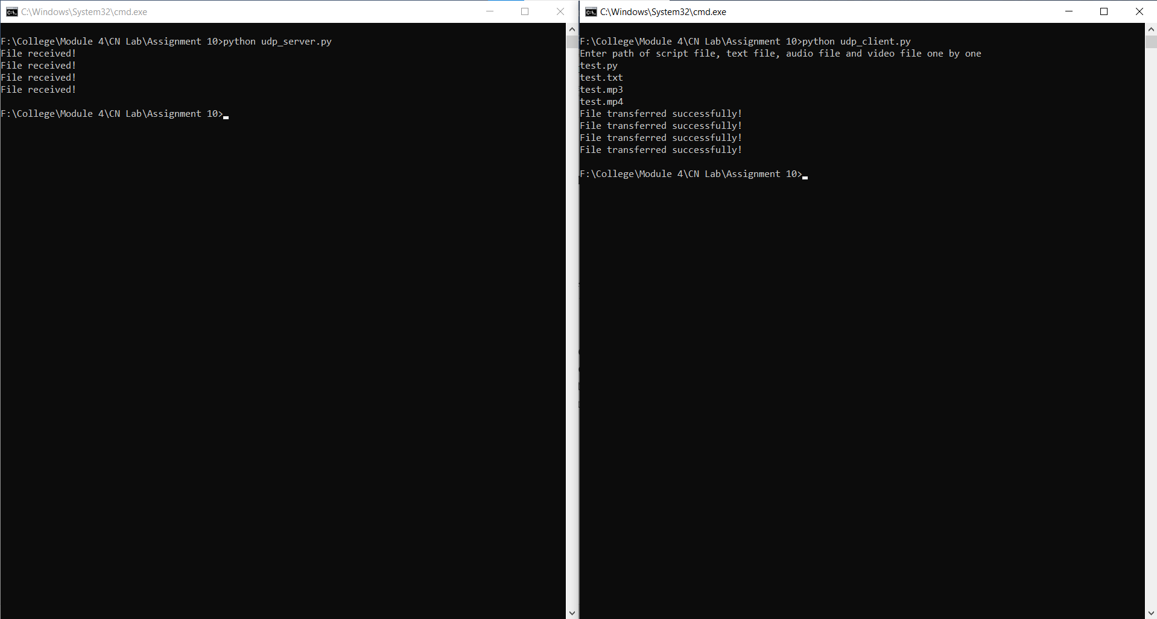

**Conclusion:**

In this assignment, we have successfully implemented file transfer using UDP and also learned about packetizing.